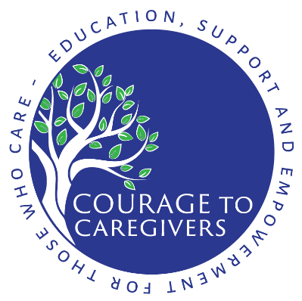

NEWS RELEASE

FOR IMMEDIATE RELEASE Contact: Kristi Horner
www.CourageToCaregivers.org 216-536-7699

Courage to Caregivers Launches New Self-Care Support Program for Caregivers and Loved Ones of Those Living with Mental Illness
- Program focuses on the importance of caregivers being able to take care of themselves
- Participants connect one-to-one with volunteers who have experience caring for people with mental illness
- Pilot program is first of three planned by Courage to Caregivers to educate, support and empower those who care for loved ones living with mental illness

CHAGRIN FALLS, Ohio – October 24, 2018 – Recognizing that self-care is the “oxygen mask” for the mental illness caregiver, Courage to Caregivers is accepting applications for volunteers and participants in the launch of its One-to-One Caregiver Support program.

The program connects caregivers with volunteers who have experience caring for someone living with a mental illness. The purpose of the program is to provide participants with training and resources to help them take care of themselves both physically and emotionally so they are better able to take care of their loved one.

“We are excited to offer this, our first of three planned programs, to support self-care for mental illness caregivers,” said Kristi Horner, Founder and Executive Director of Courage to Caregivers. “The role of the One-to-One Volunteer will be to help the caregiver understand that they are not alone. The volunteer will offer a listening ear, a strong sense of understanding, a sense of hope, experience-based support and a safe place to share. The caregiver will receive training, resources and empowerment to gain greater strength and energy to continue their work.”

Courage to Caregivers is a nonprofit organization founded in 2017 to provide education, support and empowerment for caregivers and loved ones of those living with mental illness. In addition to the launch of the One-to-One Caregiver Support program, Courage to Caregivers is developing two other pilot programs that will offer professionally led support groups and breathing/meditation classes for caregivers. More information about these programs will be announced in the near future.

The organization was formed to help people like Nancy, who found herself in need of personal support as she cared for a family member. “I was scrambling for more tools and knowledge on how to respond. I called Courage to Caregivers and was given immediate and ‘lifesaving’ attention,” Nancy said. “As I practiced and utilized the tools and tips, I also developed greater confidence and learned the importance of self-care as a caregiver. I am forever grateful for Courage to Caregivers and their tools for life!”
In the One-to-One Caregiver Support program, volunteers will be trained to share insights learned from their experiences and to introduce caregivers to activities and other resources that help promote healthy self-care practices. Volunteers will be matched with caregivers based on individual circumstances, availability and interests. All conversations between One-to-One Caregiver Support participants and their support volunteers will be strictly confidential.

“This program is the result of evidence-based research in which we found that caregivers had no place to turn for the kind of one-to-one support they yearn for,” Horner said. “We are here to help caregivers strengthen their own health and resilience so they can provide better care for others. With November being National Family Caregivers Month, focusing on the more than 44 million Americans who care for a family member, friend or neighbor, it’s appropriate that we’re launching this program now.”

The role of the One-to-One Volunteer will be to listen, care, share personal experiences and empower other caregivers. As part of the program, Courage to Caregivers will provide special training for the volunteers to:
- Empower sound decision-making;
- Provide personalized, one-on-one support;
- Share appropriate community resources; and
- Strengthen caregivers’ ability to take care of themselves both physically and emotionally.

“The One-to-One Volunteer will lend an open and willing ear by listening actively to help caregivers navigate through the journey of giving care,” said Lenora Inez Brown, author of the training webinars that will form the foundation of the program. “Many books, friends and mental health professionals often say that caregivers need to remember to take care of themselves, because if you aren’t healthy, how can you take care of the person who needs to be cared for? It’s true and necessary to take care when giving care; to find peace in caring for others.”

To apply as a volunteer or participant in the One-to-One Caregiver Support program, visit www.CourageToCaregivers.org. There will be no charge for the program, which is generously supported by a grant from Peg’s Foundation, an organization focused on improving the lives of people with serious mental illness by investing in innovative projects in Northeast Ohio.

About Courage to Caregivers
Courage to Caregivers is a nonprofit organization serving Northeast Ohio with a mission to offer hope, support, and courage to caregivers and loved ones of those living with mental illness. It was founded on the belief that when you support someone you love who is living with mental illness, it is absolutely essential to put on your own “oxygen mask” of self-care before helping those around you. In a validating, nonjudgmental environment, participants will develop the inner strength required to support their loved ones and, most importantly, to care for themselves.

For more information, contact:
Kristi Horner
Kristi@CourageToCaregivers.org
(216) 536-7699
www.CourageToCaregivers.org

# # #

